Fairborn Parks & Recreation Advisory Board 250 Pieces of Trash Park Challenge
Track how many pieces of litter you can clean out of Fairborn parks! Every square equals 5 pieces! Reach 250 pieces to complete the challenge.
Earn a Fairborn 250 sticker (first come, first served) You can pickup your sticker from the City of Fairborn Parks Office or from the Park Board Root Beer tent at city events.

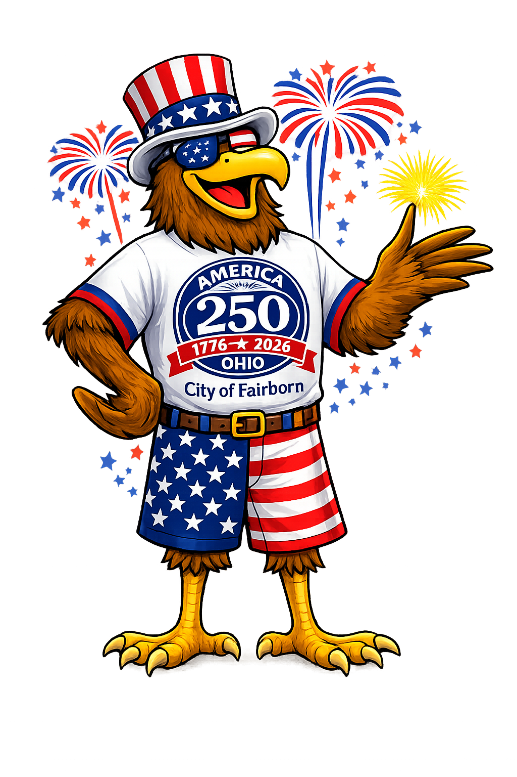

5 | 10 | 15 | 20 | 25 | 30 | 35 | 40 | 45 | 50
55 | 60 | 65 | 70 | 75 | 80 | 85 | 90 | 95 | 100
105 | 110 | 115 | 120 | 125 | 130 | 135 | 140 | 145 | 150
155 | 160 | 165 | 170 | 175 | 180 | 185 | 190 | 195 | 200
205 | 210 | 215 | 220 | 225 | 230 | 235 | 240 | 245 | 250

